Write the following C++ program, to be used for the debugging practice. This program computes and prints the factorial of n (=1*2*3*...*n). The program, however, has a logical error and produce a wrong answer for n=20. (It outputs "The Factorial of 20 is -2102132736" - a negative number?!).
1  2  3  4  5  6  7  8  9  10  11  12  13  14  15  16  17  18  19 | /*  * Compute the factorial of n, with n=20.  * n! = 1*2*3*...*n  */  #include <iostream>  using namespace std;  int main() {  int n = 20; // To compute factorial of n  int factorial = 1; // Initialize the product to 1  int i = 1;  while (i <= n) {  factorial = factorial * i;  i++;  }  cout << "The Factorial of " << n << " is " << factorial << endl;  return 0;  }

Run the program and observe the output produced:
The Factorial of 20 is -2102132736

Let's use the graphic debugger to debug the program.

Step 1: Set an Initial Breakpoint
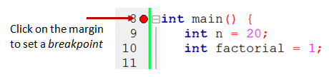
Set an initial breakpoint at main() function by clicking on the "left-margin" (right-side of the line number) of the line containing main(). A red circle appears indicating a breakpoint has been set at that line. A breakpoint suspends program execution for you to examine the internal states.

Step 2: Start Debugging
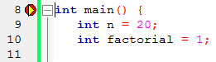
From "Debug" menu, select "Start (F8)". The program begins execution but suspends its execution at the breakpoint, i.e., main(). An yellow arrow (as shown in the diagram) appears and points at the main(), indicating this is the next statement to be executed.

Step 3: Single-Step and Watch the Variables and Outputs
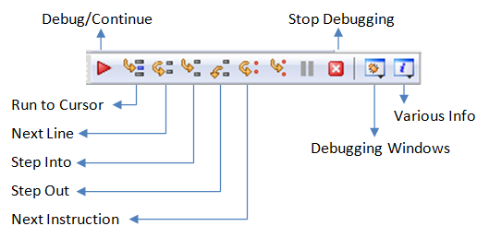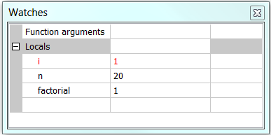

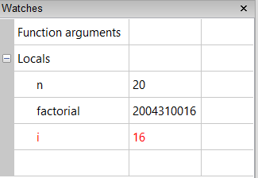

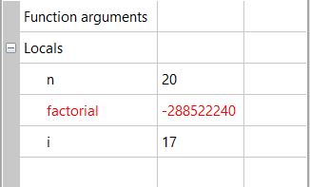
Click the "Debugging Windows" button on the "Debug" toolbar and select "Watches" to enable the "Watch" pane. (You could also do it from the "Debug" menu.)
Click the "Next line" button on the "Debug" toolbar to single-step thru your program. At each of the step, you could examine the internal state of your program, such as the value of the variables (in the "Watches" pane), the outputs produced by your program (in the console), etc.
Single-stepping thru the program and watching the values of the variables and the outputs produced is the ultimate mean in debugging programs - because it is exactly how the computer runs your program!

Step 4: Breakpoint, Run-To-Cursor, Continue and Stop
As mentioned, a breakpoint suspends program execution and let you examine the internal states of the program. To set a breakpoint on a particular line, click the left-margin of that line (or select "Toggle Breakpoint (F5)" from "Debug" menu).
The "Continue" resumes the program execution, up to the next breakpoint, or till the end of the program.
Single-stepping thru a loop with a large count is time-consuming. You could set a breakpoint at the statement immediately outside the loop (e.g., Line 12 of the above program), and issue "Continue" to complete the loop.
Alternatively, you can place the cursor on a particular line, right-click and select "Run-To-Cursor" to resume execution up to this line.
The "Stop" ends the debugging session. Always terminate your current debugging session using "Stop" or "Continue" till the end of the program.
Important: I can's stress more that mastering the use of debugger is crucial in programming. Explore the features provided by the debuggers.

Other Debugging Features
Step-Into and Step-Out: To debug a function, you need to use "Step-Into" to step into the first statement of the function. ("Step-Over" runs the function in a single step without stepping through the statements inside the function.) You could use "Step-Out" to return to the caller, anywhere within the function. Alternatively, you can set a breakpoint inside a function.
Watching a Variable: To add a variable into the "Watches" panel, goto "Debug" ⇒ "Edit Watch..." ⇒ "Add" ⇒ Enter the variable name ⇒ You can select the format, or "watch as array".

